CS 550
October 11, 2020
Project 2

Name: Tianle Yuan
Email: yuant@oregonstate.edu
Project Number: 2
Project Name: Hierarchical Transformations
Web Link: https://media.oregonstate.edu/media/t/1_2hy5yo3v
Screen Captures：

The shape in front of my helicopter is the LoG function. For the outside view point, I have set it as: gluLookAt( 10, 10, 10 , 0., 0., -3. , 0., 1., 0. );
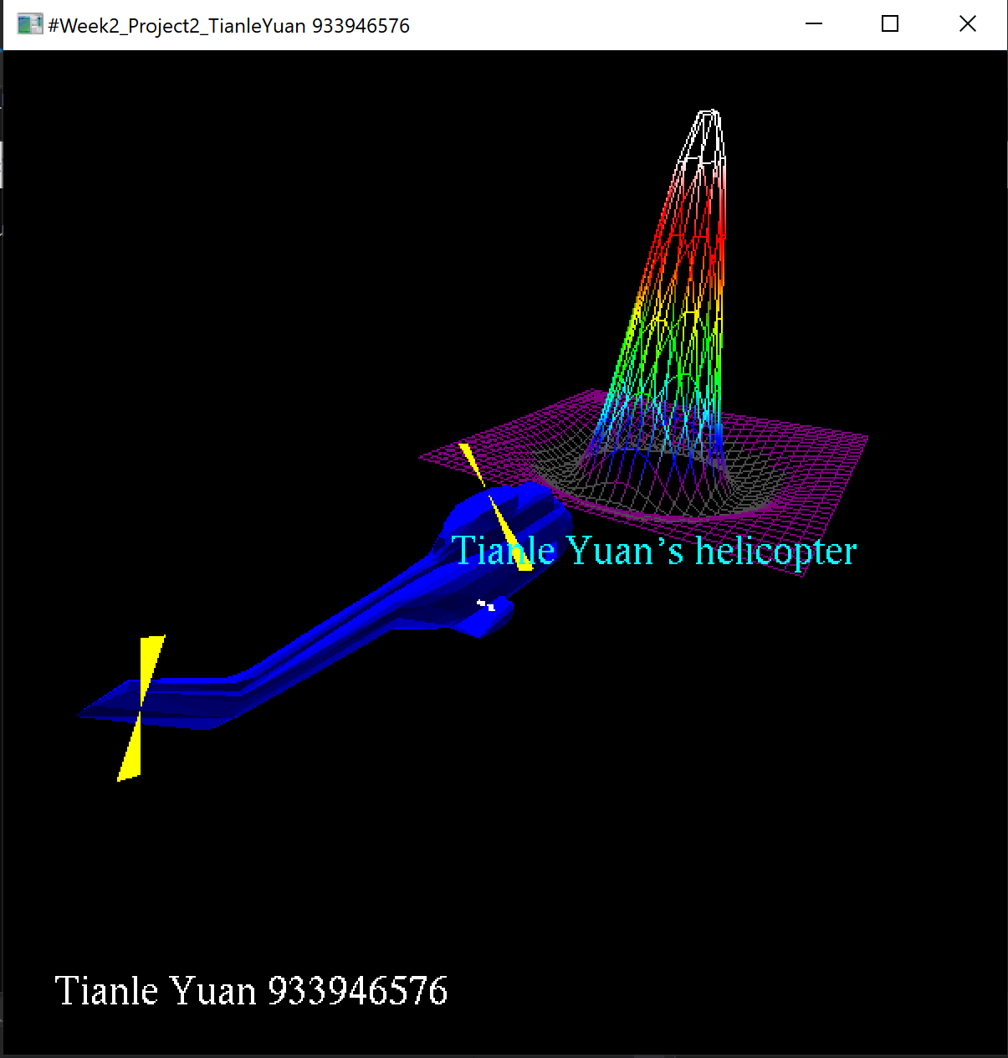

For the inside view point, I have set it as: gluLookAt( -0.4, 1.8, -4.9, -0.4, 1.8, -10., 0., 1., 0. );.
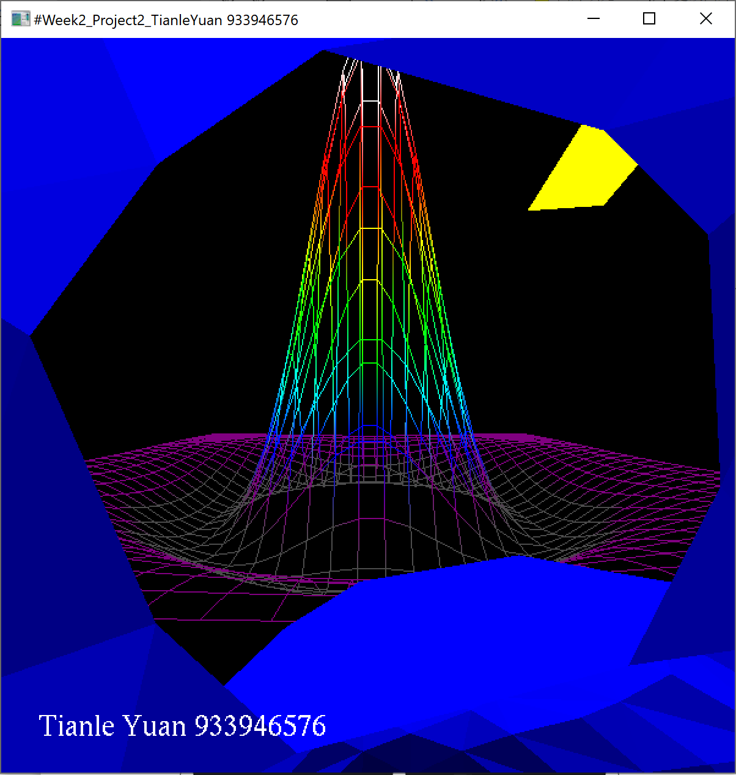
The blades’ size and position:
